EETC-1314
Lab #1
AC Fundamentals: Oscilloscope

Student Name: _________________________________ Date: ___________

Instructor Signature:_________________________________ Date: ___________

Point Assignment: ________________________

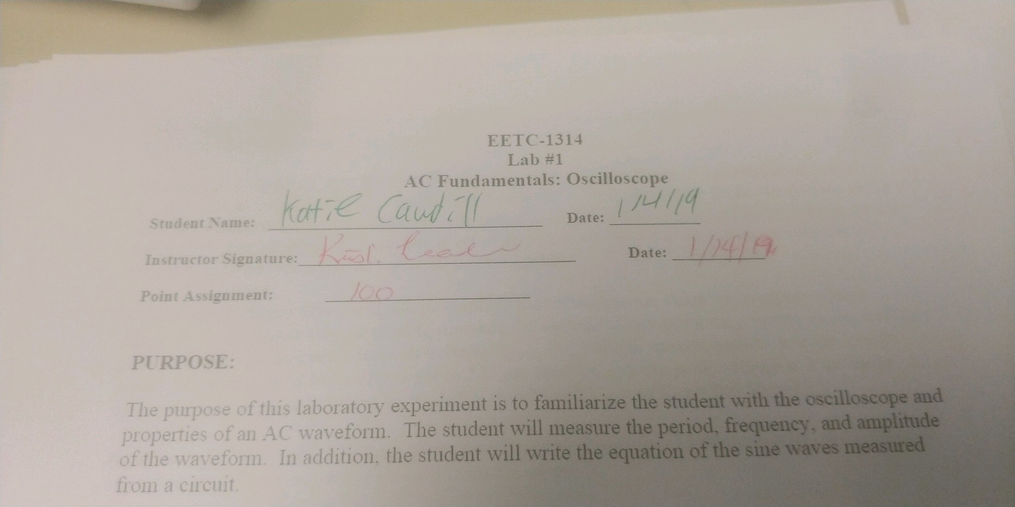
PURPOSE:

The purpose of this laboratory experiment is to familiarize the student with the oscilloscope and properties of an AC waveform. The student will measure the period, frequency, and amplitude of the waveform. In addition, the student will write the equation of the sine waves measured from a circuit.

BACKGROUND:
The oscilloscope is the key test and measurement instrument used for studying time varying waveforms. It displays a waveform on a screen where amplitude(voltage), frequency, period, phase displacement, etc. can all be measured. Measuring a signal requires two connections, a measurement lead and a reference lead. The reference is often referred to as “ground” because it is a “grounded connection” on most oscilloscopes.

Inputs Controls: There are typically two- or four- input channels on an oscilloscope. Each channel has buttons that permit you to select AC or DC coupling or Ground. DC coupling displays the entire signal, dc plus any ac present. The AC selection blocks any dc component present. Ground disconnects the input signal and connects to ground which is useful for determining a zero reference.

Vertical Controls: The main vertical control is the Volts/Div scale. It sets the scale for the Y-axis. For example, when set to 10V/Div, each major division on the Y-axis represents 10 volts. Each channel has its own control for Volts/Div. Another control is provided for the Vertical position of each channel that moves the entire waveform up or down.

Horizontal Controls: The main horizontal control is the Time/Div scale. It sets the time per division scale for the X-axis in s, ms, µs, or other units. For example, when set to 10ms/Div, each major division on the X-axis represents 10 ms. Only one Time/Div control is provided for all channels.

The Autoscale button on the Oscilloscope will auto scale both vertical and horizontal scales or Volts/Div and Time/Div settings can be adjusted so that one cycle of the waveform is spread over the screen for more accurate measurements.

Trigger Controls: Triggering captures and displays a stable waveform on the screen. The trigger source selects the waveform from which to trigger, for example Ch0 or Ch1. The trigger type is how data acquisition will begin and is either immediate (default) or edge triggered. The trigger slope, level, and horizontal position are only used for the edge triggered type and selects how and where the scope is triggered.

Measuring Frequency and Period: The frequency (f) of a waveform is its number of cycles per second, and its period (T) is the duration of one cycle. Using the X-axis scale, the period can be measured directly on an oscilloscope. The relationship f = 1/T can then be used to determine the frequency. For example, if Time/Div is set to 20 µs per division and one cycle is 4 divisions, then T = 4(20 µs) = 80 µs and f = 1/(80 µs) = 12.5 kHz.

Measuring Voltage: The oscilloscope displays the instantaneous value of its input voltage. Thus, an oscilloscope may be used to measure the voltage at any point on a waveform as well as peak voltage(V_{m}) and peak-to-peak voltage(V_{p-p}). For voltage measurements, use the Y-axis scale. For example, if Volts/Div is set to 2 V per division and the peak voltage is 3 divisions above the reference point, then V_{m} = 3(2 V) = 6 V and V_{p-p} = 2(V_{m}) = 2(6 V) = 12 V.

Equations for Sinusoidal Voltage from Oscilloscope Readings: Mathematically, the voltage at any point on a sine wave can be found from the equation

v(α)= V_{m} sin (α)

where V_{m} is the peak voltage and α is the angular position on the cycle according to the X-axis. If the peak voltage is known, the voltage at any point can be determined by direct substitution. For the angular position α, one cycle represents 360°, one half-cycle represents 180°, one quarter-cycle represents 90°, and so on.

Voltage as a Function of Time: The voltage converted to an equation that is a function of time instead of angular position makes for a more useful equation for our purposes. That equation is as follows

v(t)= V_{m} sin (ωt)

where ω is the angular velocity and t is time measured in seconds. The angular velocity ω is a function of the frequency or period of the waveform such that ω = 2πf = 2π/T. We can now measure the peak voltage and the period from the oscilloscope and therefore, obtain the equation for the sinusoidal waveform. Using this equation, the value of the voltage can be found at any point in time. This value is called the instantaneous value.

PROCEDURE: Using the NI ELVIS II Oscilloscope and Function Generator
PART I.
- Open the Function Generator from the NI ELVISmx Instrument Launcher.
- Choose the Sine Wave as the waveform.
- Signal Route can be FGEN BNC to send signal to a BNC connector or Prototyping Board to send the signal to FGEN on the circuit board.
- Open the Oscilloscope from the NI ELVISmx Instrument Launcher.
- Choose desired channel options.
- Connect the scope leads for the appropriate channels. On the NI ELVIS II oscilloscope, Ch0 and Ch1 can be used with BNC connectors or the Analog Inputs can be used from the circuit board.
- Connect the scope red (positive) lead to measurement point and connect the black (negative) lead to the circuit ground. The black lead must be connected to ground in the circuit because it is internally grounded. To start, directly measure the output of the Function Generator.
- Run the Function Generator and the Oscilloscope.
- (10%)Measuring Period and Frequency:
  - Set the oscilloscope time base to 100 µs/Div and coupling to AC. Adjust the frequency dial on the function generator to obtain a sine wave that is five divisions in length. From the oscilloscope screen, determine the period, T and the frequency, f. Compare the measured frequency to the frequency set on the dial.
T = ___500us______
f = 1/T = _____2kHz_____ and f_{dial} = ___2kHz______

  - Next, set the oscilloscope time base to 25 µs/Div. Adjust the frequency dial on the function generator to obtain a sine wave that has two cycles in eight divisions. From the oscilloscope screen, determine the period, T and the frequency, f. Compare the measured frequency to the frequency set on the dial.
T = ___80us______
f = 1/T = ___12.5kHz_______ and f_{dial} = ____12.5kHz_____

- (10%)Measuring Voltage:
  - Set the oscilloscope voltage scale to 0.5 V/Div and choose a frequency of 2 kHz on the function generator. Adjust the amplitude dial of the function generator to display a sine wave of six grid lines peak-to-peak. From the oscilloscope screen, determine the peak voltage and the peak-to-peak voltage. Compare the measured peak-to-peak voltage to the peak-to-peak voltage set on the dial.
V_{m} = ____1.5V_____
V_{p-p} = _____3V____ and V_{p-p(dial)} = ____3V_____

PART II.
1. (20%)For the sinusoidal waveform shown in figure #1, the period measured from t₁ to t₂ is 500 μs and the vertical scale is 2 Volts/Div. Find the frequency, the angular velocity(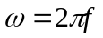), the peak voltage, and the peak-to-peak voltage.

t₁
t₂

Figure #1: AC Voltage Waveform

Table #1
Waveform Variable | Response w/Units
Period (T) | 500 µs
Frequency (f = 1/T) | 2kHz
Angular Velocity (ω = 2πf) | 12.6 k
Peak Voltage (V_{m}) | 5V
Peak-to-peak Voltage (V_{p-p}) | 10V
Equation: v(t) = V_{m} sin(ωt) | V*sin(12.6t)

2. (30%)For the circuit shown in Figure #2, the voltage source has an amplitude of 5V (peak) and a frequency of 2kHz. Build the circuit on the ELVIS using the function generator as the source voltage. Measure the source voltage, the R₁ voltage and the R₂ voltage. Figure #2 is set up to measure the source voltage and the R₁ voltage. Figure #3 is set up to measure the source voltage and the R₂ voltage.
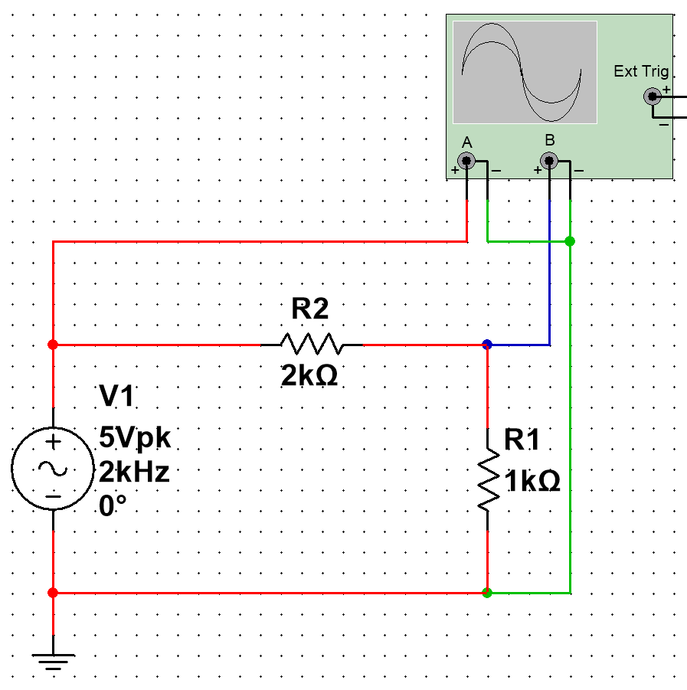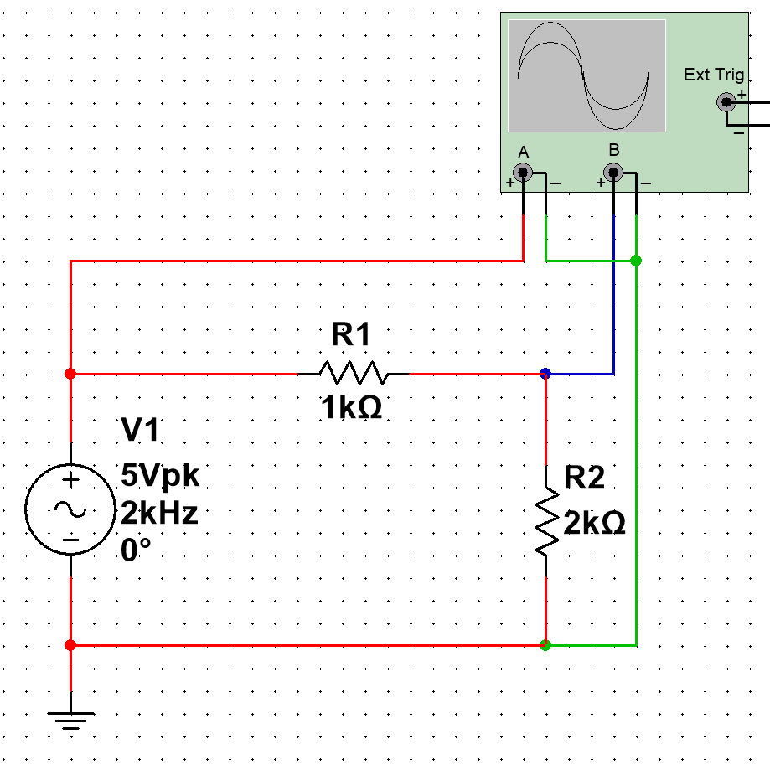
Figure #2 Figure #3

Use the oscilloscope screen and the cursors to determine the values for voltages at the specified times. Place one cursor as close as possible to a zero point on the waveform as it is rising. This first cursor is the 0 time. Use the other cursor to move along the waveform at the appropriate time intervals by looking at the time difference between the two cursers.

Table #2 – Values Measured from Oscilloscope
Time | Source Voltage | Resistor R₁ Voltage | Resistor R₂ Voltage
0 | 0 V | 0 V | 0
50μs | 2.88 V | 976 mV | 1.96 V
100μs | 4.66 V | 1.58 V | 3.15 V
150μs | 4.66 V | 1.58 V | 3.15 V
200μs | 2.88 V | 976 mV | 1.96 V
250μs | 0 V | 0 | 0
300μs | -2.88 V | -976 mV | -1.96 V
350μs | -4.66 V | -1.58 V | -3.15 V
400μs | -4.66 V | -1.58 V | -3.15 V
450μs | -2.88 V | -976 mV | -1.96 V
500μs | 0 V | 0 | 0

3. (30%)Using the peak values of the waveforms above and the frequency, write the sinusoidal waveform equations for the source voltage and the voltage drops across R₁ and R₂. [v(t) = V_{m}sin(ωt), where ω = 2πf] Using a spreadsheet calculate the voltage for the times listed below. Plot the measured and calculated waveforms on the same graph and attach the graph to the lab report.

Source voltage: v_{S}(t) = _________ 5*sin(12566t)____________________

R₁ voltage: v_{R1}(t) = ___________ 1.67*sin(12566t)___________________

R₂ voltage: v_{R2}(t) = ___________ 3.33*sin(12566t)___________________

Table #3 – Values Calculated from Equations
